**Case study of “Shiv Shakti Rice Mill”**

**A Proposal report for the BDM capstone Project**

**Submitted by**

**Name: Digpal Singh**

**Roll number: 21F3001362**



IITM Online BS Degree Program,

Indian Institute of Technology, Madras, Chennai

Tamil Nadu, India, 600036

# Executive Summary:

Grocery purchasing from a store or online, is not only a need of our daily lives but it plays a vital role in maintaining our well-being and healthy body. If we look from business point of view, it is very crucial to maintain proper inventory through proactive planning, higher customer satisfaction index through trust building and innovative mindset to hold strong customer base.

As described in the proposal “Shiv Shakti Mill” store is a mid-sized grocery store and currently encountering challenges of profit, inventory management and large customer base which further leading to an impact on net profit and sales volumes. Somewhat the increasing online purchasing trend also imposed challenges for local stores like “Shiv Shakti Mill” which further putting impact on overall performance of store.

This report of Mid-term submission contains information about data collection, metadata, descriptive statistics, explanation of methods of analysis as well as pictorial representation for results and findings.

I have dedicated this project to cater aforesaid issue being faced by “Shiv Shakti Mill”. The main objective of this project is to understand the actual problem related to declining profit, improper inventory management and decreasing customer base. I believe that by working upon data facts, we can provide some feasible solutions to overcome the current condition and improve the store’s overall performance.

**Main objective for Mid-Term:**

* To find higher profit margin goods.
* To find the goods having maximum sales
* To find the goods based on self-life
* To investigate Pareto principle for goods
* To investigate and negotiate the revenue and purchase price trend in the market

# Proof of originality of the data:

**Details:**

Name : **Shiv Shakti Rice Mill**

Owner : **Mr. Ramesh Yadav**

Address : Thada Road, Bhiwadi, Alwar, Rajasthan (301019)

The store sells all kind of all kinds of daily use products along with milk and dairy products. The store was established in the year 2017. The purpose of opening this store was to provide daily need products. Such store was not available nearby to this location when Mr. Yadav opened this store.

**Images:**

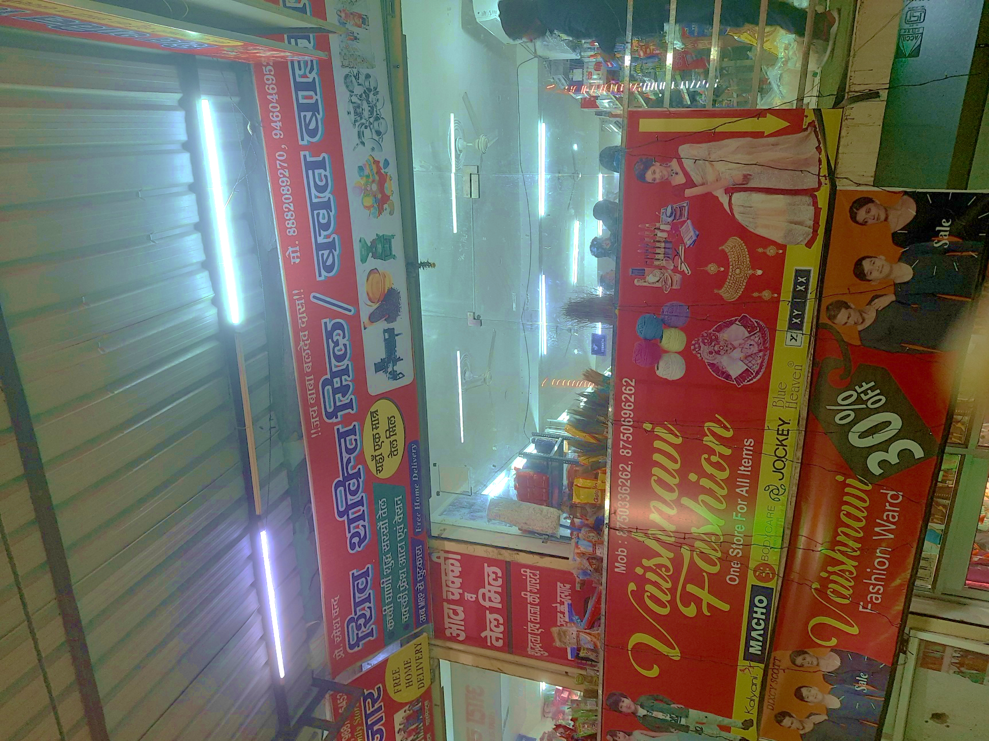To endorse my facts, visual documentation is collected comprising photos of the store along with the sample bills and informal receipts to record each sale

*Pic of the store (Outside)*

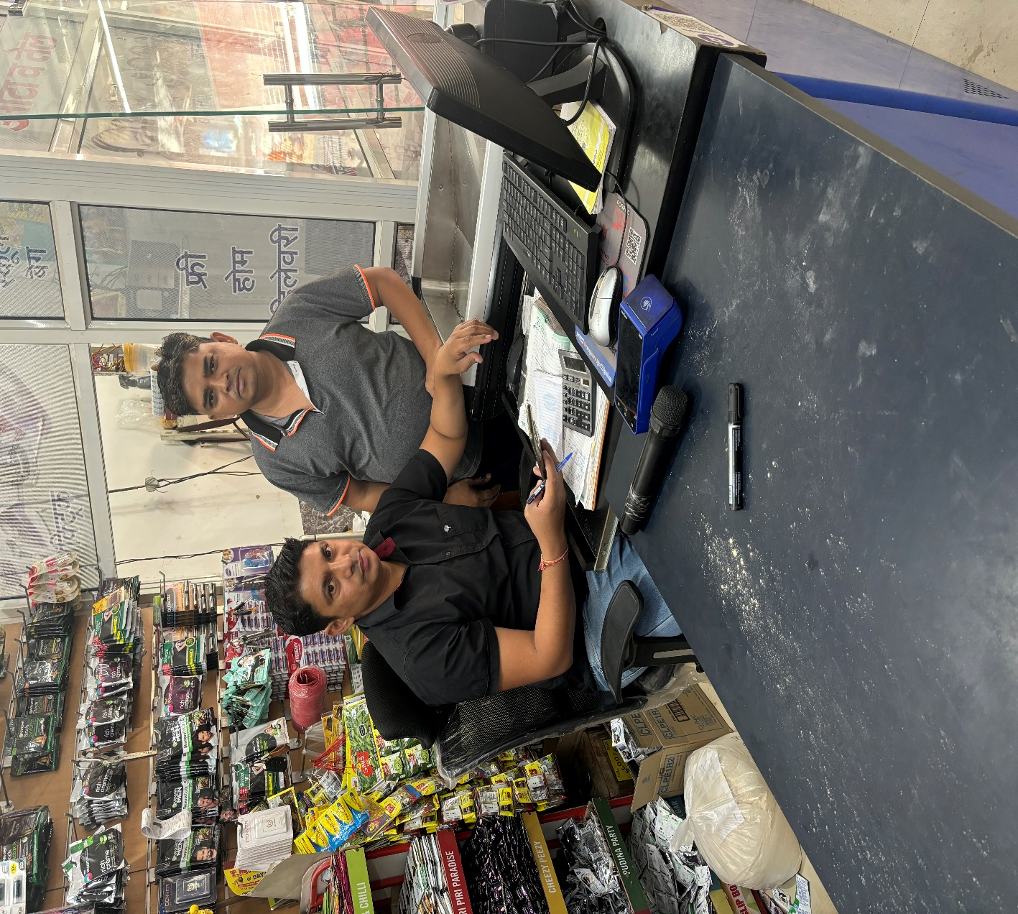

Me

Store owner

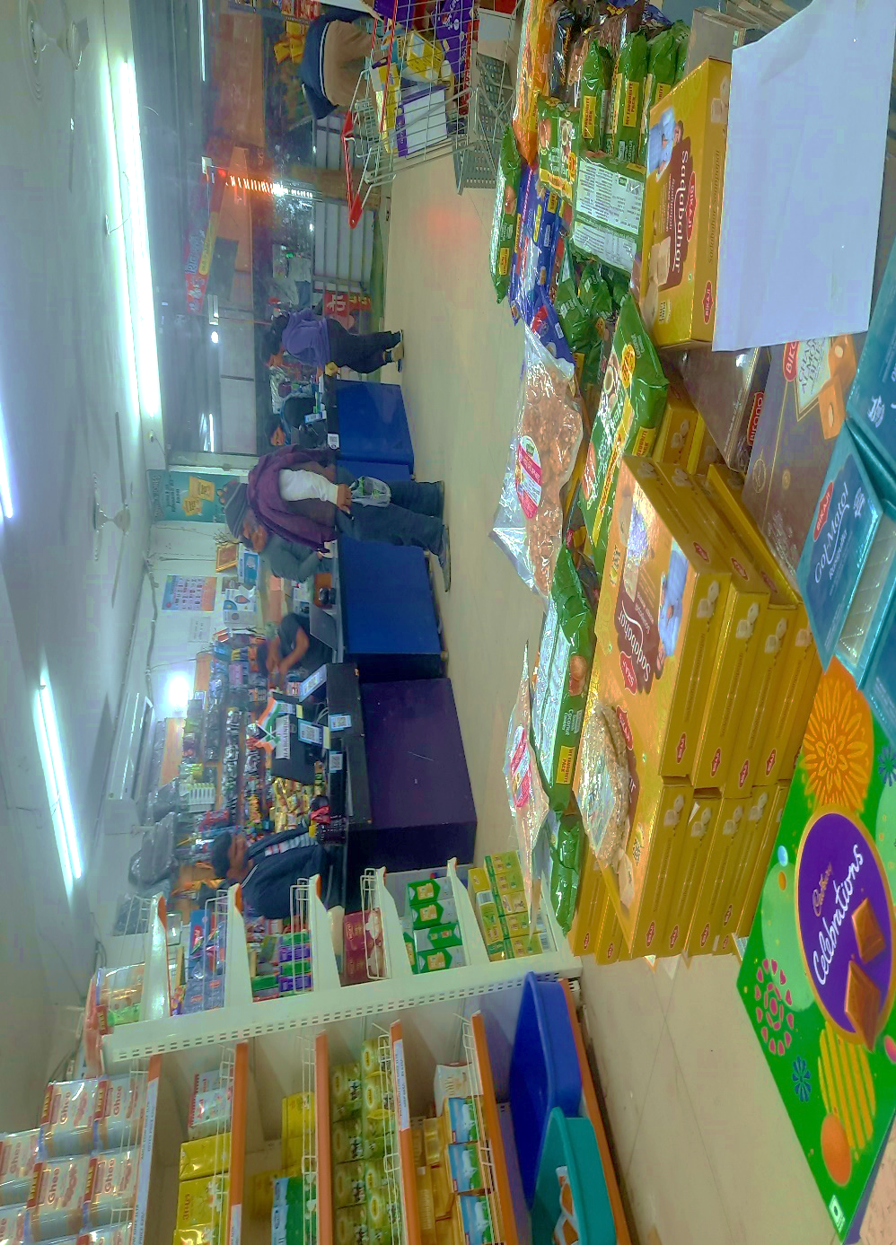

*Pic of the Store owner & me*

*Pic of the store (Inside)*

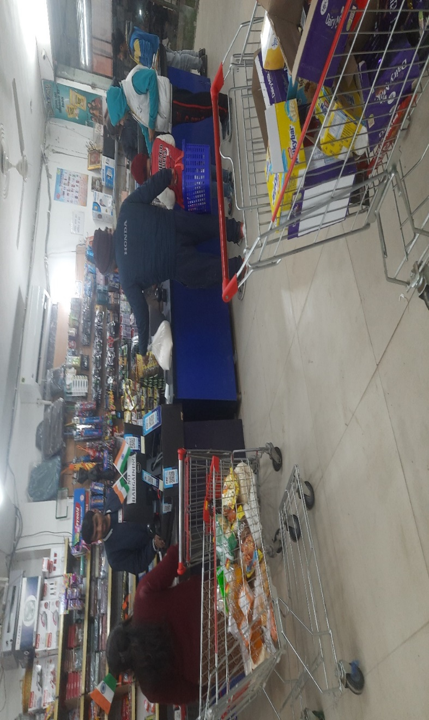

*Pic of the store (Inside)*

The store has its own integrated software to keep the sales record and print the sales receipts. However, Store’s owner doesn’t know much about how to retrieve the stored data or collection methods that can be readily available to obtain. In order to capture the store's sales records, pictures of the formal bills have been collected. While the absence of official data storage may limit the availability of documentation, these captured pictures provide valuable insights into the store's transactional activities and contribute to the overall understanding of its operational practices.

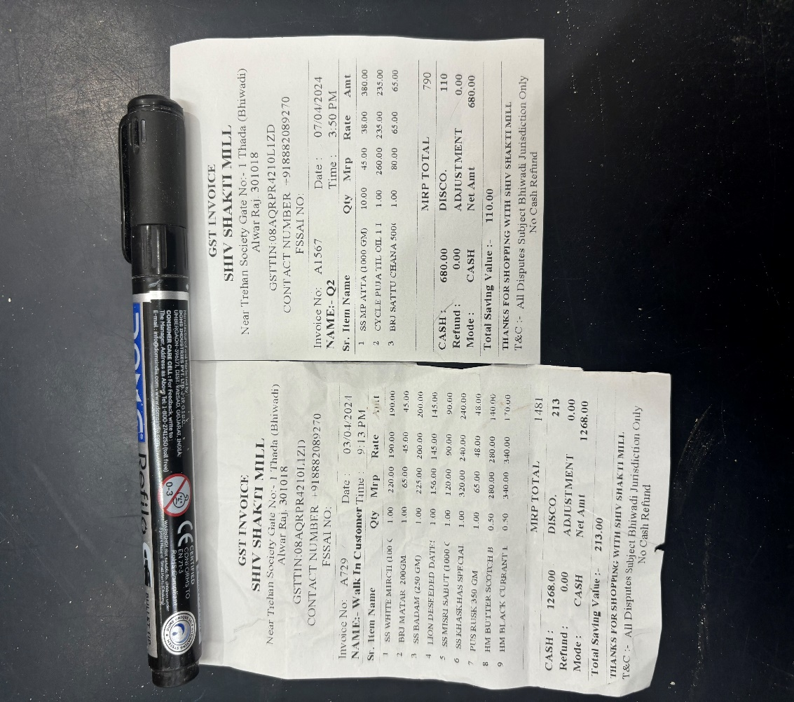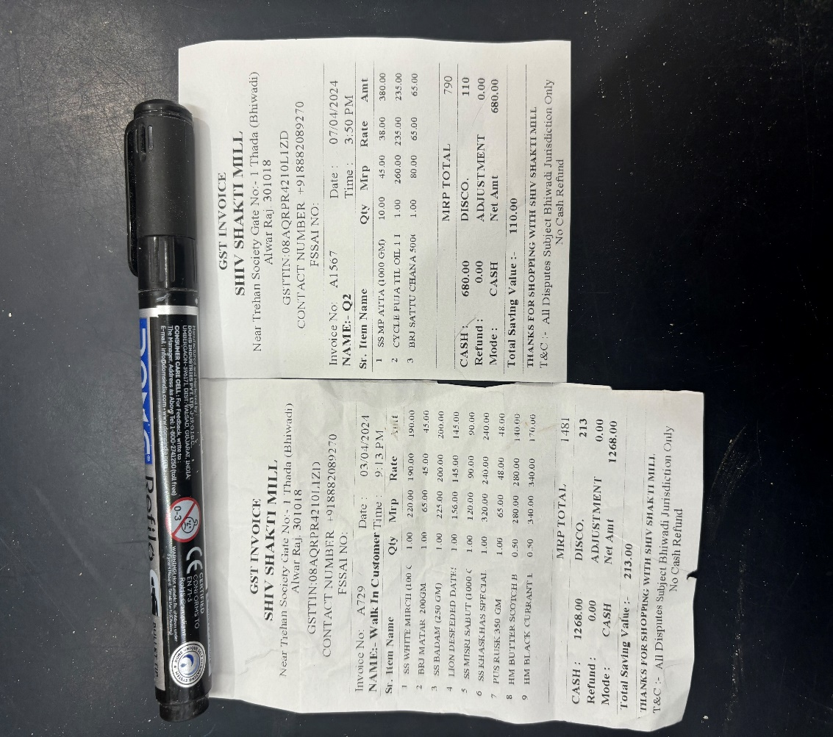

*Pic of the official bill*

# Metadata and Descriptive Statistics:

I have collected data of 31 days, starting from the 1st of February and extending until the 2nd of March 2024. Throughout this period, my data collection approach involved a combination of daily visits to the shop and strategically timed alternate-day visits, allowing me to compile a comprehensive set of cumulative data encompassing the entire time span.



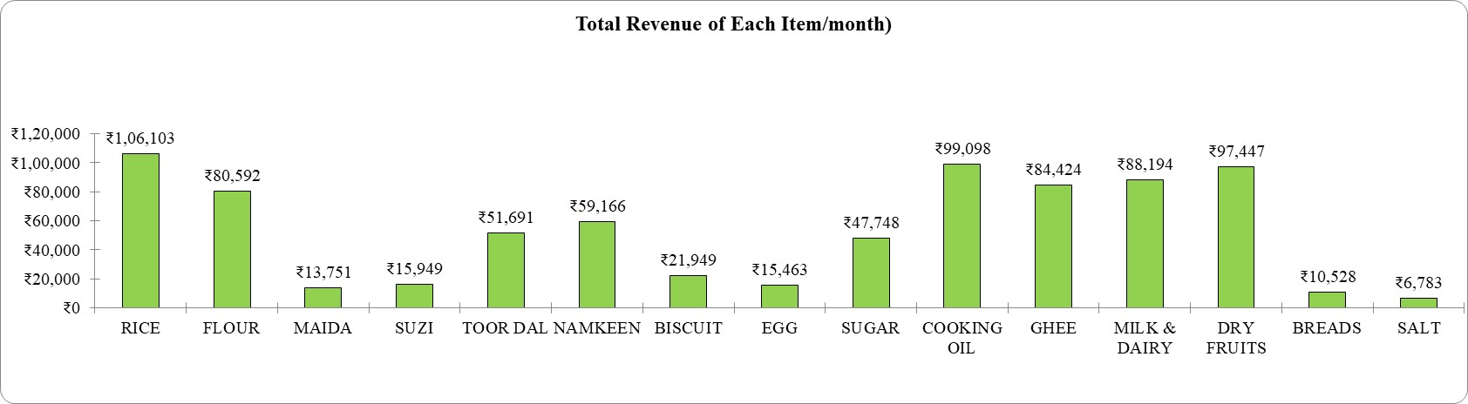

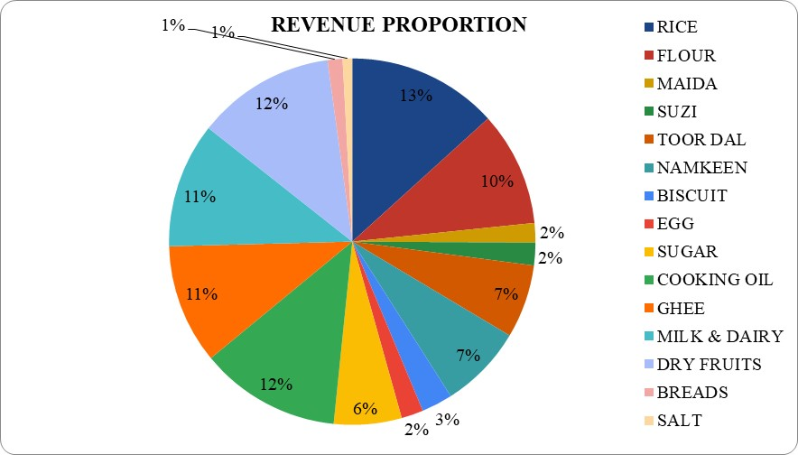

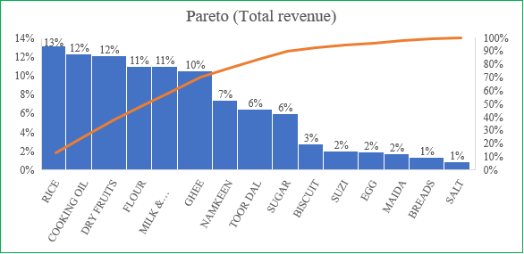

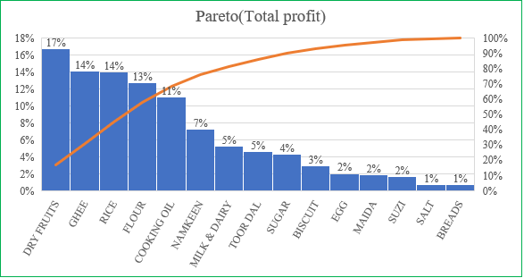

# Detailed Explanation of Analysis Process/Method:

I have collected time series data for 30 days in Google Sheets for aforementioned items and cleaned, organized and then analyzed.

As already said that data storage retrieval was not available with owner, hence I collected all the data manually and maintain it in the Google Sheets. I carefully examined the data to ensure its structure and cleanliness for effective analysis. I also checked for any kind of inconsistency or missing data or outliers that could had impact on the result. Then, I have used various descriptive statistical techniques to summarize and explore the data.

**Submitted by-**

Digpal Singh

Roll Number: 21F3001362